Anti-drone system Dronelyzer
Specification

COLD SKY TECHNOLOGIES LLC

1 Main purpose

Anti-drone system Dronelyzer with Jammer system (following - system), is used to protect private territories and property, military facilities, penitentiary service facilities, frontier regions against encroachments, invasions, terrorist attacks with usage of drones and UAV.
Sabotage
Any drone is an excellent weapon for enemy groups or vandals aspiring to inflict maximum damage over a distance. Airports, NPP, HPP, TPS, military depots and the like; protection of such facilities against UAV is extremely necessary.
Illegal Trade
Criminals have adapted drone for illegal trafficking of goods over frontiers and into secure locations such as prisons, ports and the like. Depending on unmanned aerial vehicle model, the goods weight can reach several kilograms.
Espionage
Small drones are capable of carrying nano-computers and routers, cameras and microphones. Overall panorama of territory and even video recording of your private life can be easily obtained by malicious persons.
Terror
Drones can carry grenades and other small weapons, as well as dangerous substances. It is a serious terroristic threat today to any military or civil facility.

2. Specification
Table 1.
Name | Quantity
1. Radio frequency drone detector | 4 pcs
2. Drone detection antenna in the range of 2.4 / 5.8 GHz | 8 pcs
3. Antenna for detecting drones that use WiFi | 4 pcs
4. Coupling device with drone neutralization system | 1 pcs
5. Set of high frequency cables such as DRACA, LMR or similar | 1 set
6. Set of interface cables | 1 set
7. Set of power cables | 1 set
8. Fast-switch | 1 pc
9. Fastenings for the equipment (set) | 1 set
10. Passport | 1 pc
11. Drone neutralization system | N/A
12. Guaranteed power supply system | N/A

3 Conditions of use

The system is designed for operation outdoors, in snow and rain, and in conditions according to Table 2.
Table 2. Conditions of use
Temperature | From - 30°С to + 40 °С
Relative humidity | From 20 to 100%
Atmospheric pressure | From 84 to 106,7 kPa

4 Technical characteristics

6.1 The system is powered by two-wire, with a cross section of 2x1.5 mm2, AC network with a voltage of 110-240 V, and a frequency of (49-61) Hz
6.2 Power consumed by the system from the AC mains in the reconnaissance mode is not more than 120 W
6.3 The systems ready to operate in no more than 5 minutes after turn on.
6.4 Dimensions: 400 х 300 х 170 mm. The appearance of the system is shown in the figure1.
6.5 Degree of protection of a product is IP65 in accordance with GOST 14254 - 96.
6.6 Operating mode - 24/7
6.7 The cooling system contains fans
6.8 Indication - LED indicator on the power supply, screen to monitor the operation of the system, sound indication
6.9 Drone Detector
6.10.1 Number of independent drone detection channels - 4. Number of RF inputs of antenna connection - 8 pcs + 4 pcs WiFi
6.10.2 The detection range depends on the humidity and the height of the antennas above the surface, at a height of 0 m the detection distance is 1 km, at a height of 3 m the detection distance is 2 km, at a height of 30 m the detection distance is 5 km at relative humidity less than 40%.
6.10.3 Drone detection frequencies are shown in Table 3

Table 3. Frequencies
Center frequency, MHz | Band, MHz | Antenna type | Radiation pattern,  degree | Possibilities of direction detection
2440 | +/- 112 | Directional | 45 | Approach side
5500 | +/- 504 | Directional | 45 | Approach side
For drones that use WiFi
2400/5200 |  | Directional | 90 | Approach side

6.10.4 Types of signals detected in automatic mode:
- Signals from DJI Drones Ocusync and Lightbridge are detected by analysis of the shape and other parameters of the spectrum;
- WiFi signals from WiFi networks of general purpose are detected but separated from the total number of signals by analyzing the shape and other parameters of the spectrum;
- WiFi signals from DJI, Parrot, Yuneec, Hubsan drones are detected by reading "Header";
- WiMAX signals, PAL / NTSC analog transmitters, narrowband and noise signals.
6.10.5 Method of processing and detection - SDR and streaming digital signal processing. Memorization of signals and radio conditions in the internal memory for up to 1 month for further postponed analysis
6.10.7 Autonomous operation and remote control via laptop or smartphone
6.10.8 The probability of system error when detecting drones in automatic mode is less than 1%
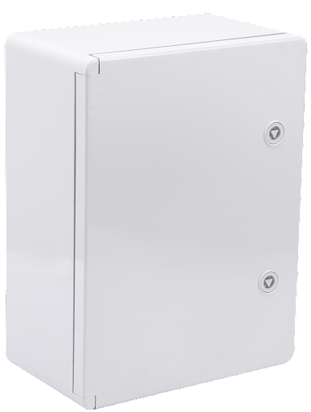
Fig. 1.

6.10.9 The probability of system error of location detecting drones in automatic mode is less than 15 degrees. The screen of Web interface of Drone Detection System shown on Fig.2.

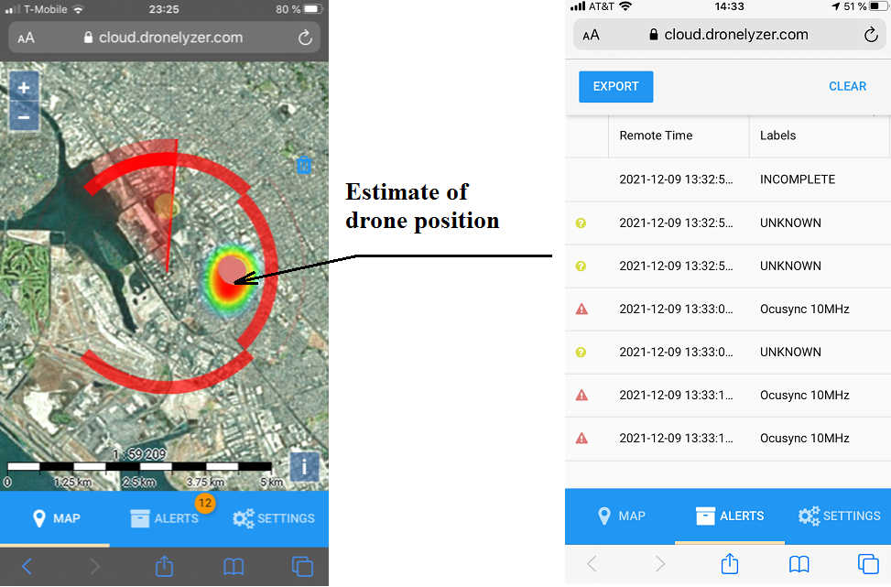
Fig. 2.

